**Proposal: Advanced Fake Account Detection &**

**Verification Framework**

Team Name - **The Encryptors**

[Harshal Borkar](https://www.linkedin.com/in/harshalborkar/), [Kunal Rathi](https://www.linkedin.com/in/kunal-rathi-a8a801268/), [Swayam Singh Bora](https://www.linkedin.com/in/swayam-singh-bora-s309b/)

## 

## **Problem Statement**

Social media platforms are increasingly targeted by fraudsters who create fake accounts to impersonate well-known individuals, engage in scams, and manipulate public perception. Traditional countermeasures like manual reporting, rule-based filtering, and basic AI moderation fail to scale effectively. Furthermore, as cybercriminals leverage automation and sophisticated techniques, detecting and mitigating fake accounts becomes increasingly challenging. This report proposes a multi-tiered approach leveraging AI, machine learning, and government-backed identity verification to systematically detect, prevent, and eliminate fraudulent accounts while maintaining user privacy and platform integrity.

## **Abstract**

The rapid growth of social media has led to an increase in identity theft, impersonation, and social engineering frauds. Existing fraud detection systems struggle to handle large-scale threats efficiently due to the evolving nature of cyber threats. Our proposed framework introduces a robust, AI-driven solution that combines government-backed authentication, anomaly detection, and behavioral analysis to improve security and trust. By integrating advanced algorithms and scalable cloud-based verification, this system significantly enhances the ability of digital platforms to mitigate fake accounts and fraudulent activities. Additionally, this approach adapts to emerging threats by utilizing self-learning AI models that continuously refine their detection capabilities.

## 

## **Proposed Solution**

**Our solution consists of two main components:**

1. **Secure Registration Mechanism:**
   * **Standard Registration:** Users sign up via email or phone.
   * **Government-Backed Verification:** Users verify their identity via a trusted cloud service (e.g., DigiLocker) to receive a verification badge, which enhances credibility and reduces impersonation risks.
2. **AI-Powered Fake Account Detection:**
   * **Behavioral Analysis:** AI detects unnatural activity patterns and engagement anomalies.
   * **Anomaly Detection Models:** Identify accounts with suspicious follower growth, engagement, and spam-like behavior.
   * **Automated Risk Scoring:** Classifies accounts based on threat levels, enabling real-time decision-making.
   * **Dynamic Enforcement:** High-risk accounts undergo verification, restriction, or suspension, ensuring prompt action against fraudulent users.
   * **Prevention Measures:** it includes in-app warnings about common scam patterns, regular user notifications on security best practices, and real-time alerts for suspicious activities.

## **Technical Approach and Technologies Used**

### **1. Fraud Prevention During Registration**

* **Government-Verified Authentication:** Enhances trust with verifiable identities, making impersonation more difficult.
* **Two-Factor Authentication (2FA):** Adds an extra security layer, minimizing unauthorized account access.

### **2. AI-Powered Fake Account Detection**

#### **A. Detecting Rapid Follower Growth**

* **Technology:** Unsupervised Learning Models (Isolation Forests, Local Outlier Factor).
* **Method:** Identifies anomalies in follower growth trends and artificial engagement rings.
* **Additional Step:** Time-based analysis of engagement spikes to detect sudden suspicious activities.

#### **B. Identifying Duplicate Profile Pictures**

* **Technology:** FaceNet, OpenCV, Perceptual Hashing.
* **Method:** Uses facial recognition, reverse image search, and image fingerprinting to detect duplicate visuals.
* **Additional Step:** AI-enhanced similarity detection to identify altered or AI-generated profile pictures.

#### **C. Detecting Accounts from the Same Location**

* **Technology:** IP and Device Fingerprinting, VPN Detection, Multi-Factor Device Tracking.
* **Method:** Tracks unusual login patterns, detects proxy and VPN use, and flags multiple accounts originating from identical devices.

#### **D. Identifying Spam Activity in DMs and Comments**

* **Technology:** NLP Models (BERT, GPT-based analysis), Spam Detection Algorithms.
* **Method:** Detects excessive message rates, repetitive engagement, and fraudulent language patterns.
* **Additional Step:** Context-aware NLP to distinguish between spam and genuine promotional messages.

#### **E. Identifying Automated Engagement and Bot Activity**

* **Technology:** Time-Series Analysis, Interaction Network Mapping, AI-Driven Behavioral Clustering.
* **Method:** Tracks automated interactions, analyzes unnatural engagement footprints, and clusters similar behavior patterns to detect bot farms.

#### **F. Preventive Measures**

* In-app warnings about common scam patterns.
* Regular user notifications about security best practices.
* Real-time alerts for suspicious activities.

## **Implementation Workflow**

### **Phase 1: Fraud Detection Activation**

* AI continuously monitors user behavior and assigns risk scores based on detected anomalies.
* High-risk accounts flagged for further analysis to reduce false positives.

### **Phase 2: Verification Check & Behavioral Monitoring**

* Flagged accounts undergo additional verification steps, including CAPTCHA challenges and identity authentication.
* High-risk users must complete government-backed authentication to retain access.
* Suspicious activities lead to warnings, interaction restrictions, or full account suspension.

### **Phase 3: Final Classification & System Response**

* **Low-risk accounts:** Continuous monitoring without direct intervention.
* **Medium-risk accounts:** Temporary restrictions and verification requests.
* **High-risk accounts:** Immediate suspension or removal from the platform, preventing further fraudulent activities.

## **Flowchart**

1. **User Registration**
   * Input: Email/Phone or Government Verification.
   * Output: Standard or Verified User.
   * Security Measures: CAPTCHA, 2FA Implementation.
2. **Fraud Detection and Anomaly Detection**
   * AI Monitors Activity → Detects Suspicious Patterns → Assigns Risk Scores.
   * Real-time Alerts for Potential Fraudulent Accounts.
   * Anomaly Detection and Flagging:

* Rapid Follower Growth
* Duplicate Profile Pictures
* Same Location Logins
* Spam Activity
* Automated Engagement
  + Additional Pattern Matching for AI-generated Content and Synthetic Accounts.

1. **Multi-Layer Verification**
   * High-Risk Accounts: Government Authentication Prompt.
   * Medium-Risk Accounts: Continued Behavioral Monitoring.
   * Adaptive Response Based on AI Learning Mechanisms.
2. **Risk Classification and System Response**
   * Low Risk: Monitoring
   * Medium Risk: Warnings
   * High Risk: Restriction/Suspension
   * Data Stored for Future Reference and Trend Analysis.
3. **Account Verification and Enforcement**
   * Verified Accounts → Trust Badge Assigned → Higher Trust Levels.
   * Fraudulent Accounts → Suspended or Removed → Further Investigation Possible.
4. **Continuous Monitoring and Adaptive Learning**
   * AI-Powered Monitoring: Continuous Activity Tracking → Behavior Analysis → Risk Scoring → Adaptive Learning Mechanisms Implemented.
5. **Risk Assessment and Classification**
   * No Risk → Normal User
   * Medium Risk → Additional Verification Required
   * High Risk → Automated or Manual Review for Further Action
6. **System Response and Enforcement**
   * Account Status Updated Based on Risk Assessment and Classification.

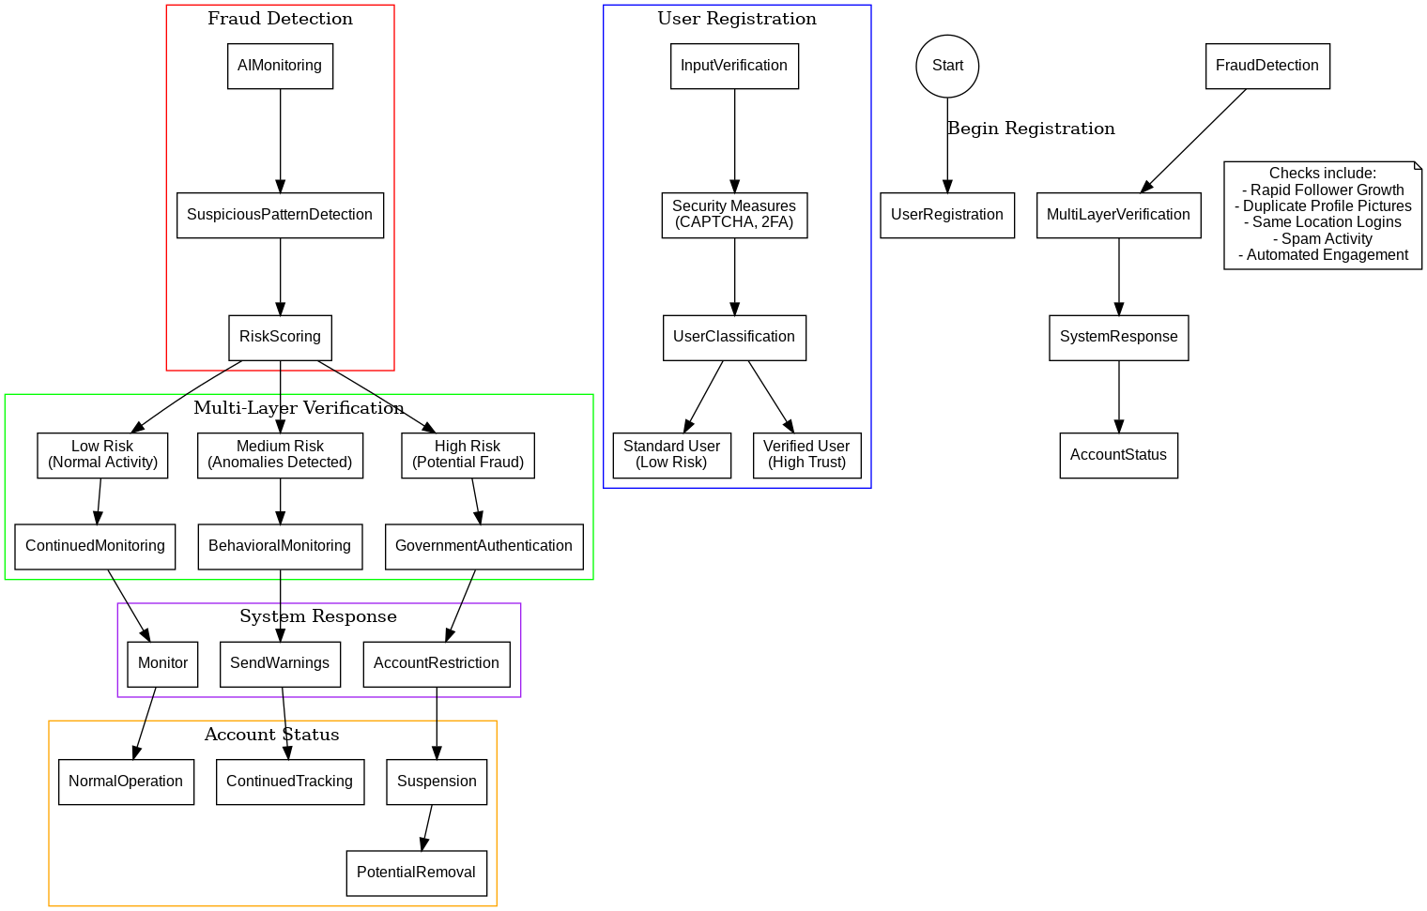



### 

### 

### 

### **Output**

1. **Verified Users Receive a Trust Badge**
   * Users who complete the government-backed identity verification will receive a trust badge on their profiles.
   * This distinguishes real users from potential fake accounts, enhancing credibility and reducing the risk of impersonation.
   * It also helps platforms prioritize verified users in recommendations, comments, and interactions, improving overall trustworthiness.
2. **Fraudulent Accounts Identified and Eliminated**
   * The system continuously analyzes user behavior, engagement, and account details to detect fraud.
   * Accounts exhibiting suspicious activities—such as rapid follower growth, spam messaging, or duplicate profile pictures—are flagged.
   * Based on risk levels, fraudulent accounts are either warned, restricted, or permanently banned to prevent further damage.
3. **AI-Based Fraud Detection and Monitoring**
   * The system automates fraud detection using AI models that evolve over time.
   * It continuously tracks new fraud patterns, such as bots, coordinated fake accounts, and synthetic identities.
   * The AI also adapts to emerging threats, improving detection accuracy and reducing false positives.

### **Conclusion**

This AI-powered fake account detection framework provides a scalable and efficient solution to mitigate fraudulent activities on social media. By integrating identity verification with machine learning, the system improves security, accuracy, and user trust. Future enhancements include deepfake detection, blockchain-based identity verification, crowdsourced fraud detection, and continuous AI model improvement. Implementing this solution ensures a safer and more transparent social media ecosystem, reducing risks of social engineering frauds worldwide and ensuring digital integrity.

### 

### **References**

**DigiLocker API Documentation**

* DigiLocker. (n.d.). *Developer Guide - API Documentation*. Retrieved from<https://digilocker.gov.in/>

**OAuth 2.0 Authentication Standard**

* Hardt, D. (2012). *The OAuth 2.0 Authorization Framework (RFC 6749)*. Internet Engineering Task Force (IETF). Retrieved from

<https://datatracker.ietf.org/doc/html/rfc6749>

**User Identity Verification Techniques**

* Jain, A., Ross, A., & Prabhakar, S. (2004). *An Introduction to Biometric Recognition*. IEEE Transactions on Circuits and Systems for Video Technology, 14(1), 4-20. doi:10.1109/TCSVT.2003.818349

<https://ieeexplore.ieee.org/document/1262027>

**Secure Cloud-Based Identity Management**

* Kaur, R., & Kaur, A. (2018). *Cloud Computing Security Issues and Identity Management*. International Journal of Computer Science and Network, 7(6), 202-208.

<https://ieeexplore.ieee.org/document/9693400>

**Multi-Factor Authentication & Digital Identity**

* Chandramouli, R., & Mell, P. (2019). *Digital Identity Guidelines*. National Institute of Standards and Technology (NIST). Retrieved from<https://nvlpubs.nist.gov/nistpubs/SpecialPublications/NIST.SP.800-63-3.pdf>